This n That

An e-mail newsletter from Agapé Athletics Club

Editor: Marieta Bortoli 082 466 7031 31 July 2017 www.agape.org.za

E-mail: marietabortoli@gmail.com

NB

- Next league race – Marcel van’t Slot (Roman’s Pizza Phobians) 19 August
- 30th Birthday party – 2 September
- 10km club championships – 2 September
- Agapé race (Jacaranda City Challenge) – 14 October Members to assist. PLEASE DIARIZE !!!!!!

Editorial

Please remember to confirm your attendance to our 30th birthday party.

Should you have some snippets from the earlier days of our club please send it to me so that I can include it in the T’nT. Former members who still receive the T’nT you are welcome to send some of your memories.

Contents

# Birthday greetings
# Personalia
# Welcome new and former members
# Congratulations
# Thank you’s
# In the mailbox
# General
# Race reports / upcoming race information
# Race results
# Training/Health snippets
# Thought of the week
# Your smile for the week
# Something to ponder over / something spiritual
# AGN league logs
# Races cancelled
# Notice Board
# Photo corner

Notice Board Additions

● Pierre van Ryneveld Night Race
● Spirit of Flight

Attachments

● 30 Year celebrations invite

Birthday Greetings
May the Lord bless you and send from above the peace of His presence, the joy of His love. May He grant you happiness in everything you do! Happy birthday!

André Breytenbach 01 August | Estelle Greyling 02 August
Hennie Greyling 02 August | Marieta Bortoli 03 August
Wallie Weder 03 August | Hennie Venter 04 August
Alfred Mangwane 06 August | Michelle van der Watt 06 August
Hans Roeber 12 August | Dietlof Ferreira 13 August
Joseph Pokwane 13 August | Marius Brummelkamp 15 August
Mari Malan 15 August | Elias Ngonyama 15 August
Stephan Badenhorst 17 August | Zanti Hattingh 20 August
Frans Molele 21 August | Gert Smith 26 August
Mario Lange 27 August | Allan Kluge 28 August

Personalia

Welcome new and former members

Congratulations

Congratulations to the following member:

Thank you’s

In the mailbox

Skukuza
We are looking for an extra Skukuza half marathon entry, if someone has one that they will not be using.
Please contact Vicki 072 283 6637

Thank you kindly
Vicki

==

Dawn to Dusk
Hallo almal

Indien daar enige lid in die klub is wat 'n spanmaat soek vir Dawn to Dusk, ek is beskikbaar.

Baie dankie
Roald le Roux
012 3489871
roaldbinah@gmail.com

General
Clothing available:
Buffs @ R100
Ladies skirts @ R200
Second skins @ R170

Please contact Marietjie if you wish to purchase some of the items:
Cell: 072 541 7268 E-mail: ventermarix9@gmail.com
The items will also be available at races, please visit our gazebo

Race reports/Upcoming race information

Race results
A4A Long Run to Freedom - 10km race - 2017-07-22
Position | Initials | Surname | Sex | Age | Finish Time
18 | J | Pokwane | M | 45 | 00:37:52
167 | D | De Beer | M | 45 | 00:49:30
170 | C | Burger | M | 32 | 00:49:44
246 | F | Schunke | M | 59 | 00:53:46
264 | W | Weder | M | 68 | 00:54:27
368 | H | Greyling | M | 47 | 00:57:32
446 | K | Nurden | M | 82 | 00:59:41
489 | B | Boyes | F | 52 | 01:00:48
595 | R | Stutterheim | M | 68 | 01:04:08
617 | D | Mahole | M | 29 | 01:04:48
881 | H | Venter | M | 57 | 01:12:56
A4A Long Run to Freedom - 21km race - 2017-07-22
Position | Initials | Surname | Sex | Age | Finish Time
64 | K | Imrie | M | 45 | 01:37:25
79 | S | Marais-werner | F | 43 | 01:39:49
110 | J | V D Merwe | M | 48 | 01:43:16
225 | A | Marais-werner | F | 43 | 01:53:52
280 | E | Fourie | F | 50 | 01:56:08
554 | M | Van Zyl | F | 54 | 02:11:50
593 | M | V D Walt | F | 45 | 02:14:54
711 | T | Lenoge | M |  | 02:22:24
764 | R | Hughes | F | 68 | 02:27:11
821 | A | Schultz | F | 40 | 02:34:59
843 | A | Diedericks | M | 26 | 02:39:30
894 | M | Venter | F | 57 | 02:50:03
918 | E | Loubser | M | 60 | 02:56:42
A4A Long Walk to Freedom - 10km race - 2017-07-22
Position | Initials | Surname | Sex | Age | Finish Time
50 | C | Mouton | F | 60 | 01:23:18
58 | K | Strauss | F | 73 | 01:28:31

Training/Health snippets

Blood Protein
Within the blood stream, there are blood proteins.

Blood proteins are responsible for holding water in the blood stream and maintaining blood volume.

91% of your blood is water.

To a certain degree, blood protein maintains blood pressure in the blood stream.

In 1930, Dr Cecil K. Drinker of the Harvard Medical School suggested that blood protein leaks from the blood stream, practically universally.

In 1948, Dr H.S. Mayerson of the Tulane School of Medicine tagged blood protein with radioactive iodine and proved that it does indeed leak from the blood stream.

In fact, he found that in a 24-hour period, a staggering 50% of blood protein could leak from the blood vessels.

In 1961, Dr Arthur C. Guyton, of the Mississippi School of Medicine, revealed that the only way to return blood protein to the blood stream is via the Lymphatic System.

Blood vessel

Cell

Blood Protein

Fluid

Lymph vessel

From this we can deduce that the only thing that can alter the Dry State is – trapped blood protein.

In the Wet State, there is a build up of blood protein and fluid around the cells and they are no longer tightly packed by the capillaries.

This means that the cells do not get their optimum ‘grocery’ delivery. They do not get their vital nutrients and even more importantly, they will not be oxygenated.

Your thought for the week

You can’t change the past, but you can ruin the present by worrying over the future!

Your smile for the week

1981 & 2005 - Two Interesting Years
Interesting year 1981
1. Prince Charles got married
2. Liverpool crowned soccer Champions of Europe
3. Australia lost the Ashes
4. The Pope died
Interesting Year 2005
1. Prince Charles got married
2. Liverpool crowned soccer Champions of Europe
3. Australia lost the Ashes
4. The Pope died
Lesson to be learned:
The next time Charles gets married, someone should warn the Pope

Something to ponder over / something spiritual


League results

Cancelled Races
- Lester Mills Night Race - 20th September 2017
- City to City – 24 September 2017

Notice Board

Useful Links:
www.raceresults.co.za/flyers - for the latest race pamphlets
www.agn.co.za/#League for the latest league logs and the league points you earned
http://www.agn.co.za/Docs/2016/WAlking/AGN%20road%20walking%20stds%20ref%20685.pdf
AGN 2016 RW qualifying standards and selection criteria
www.runawaysport.co.za Run-A-Way Sport’s web site
www.verticalhorison.co.za Trail Running www.trailseries.co.za Trail Running
http://www.mastersathletics.net/Age-Graded-Calculator.2595.0.html Age Graded Calculator
http://www.sportsinjuryclinic.net/symptom-checker By clicking where it hurts then ticking which symptoms most apply to you we can give you an indication of what injuries may apply.

Wednesday 9 August Castle Walk Road Race 10/5km
Race Organisers: Fusion Sports
Venue: Castle Walk Shopping Centre, c/o Nossob & Swakop Street, Erasmuskloof

 | 10 km | 5 km
Entry fees | R 70 | R 50
60+ / Children under 12  Toddlers under 5 |  | R 30  Free
Start time | 07h00 | 07h15
Time Limit | ??
No pets or wheelchairs on the 10km race

Pre entries at: Run-Away-Sport; Sweat Shop Southdowns & Dunkeld West & Fourways Crossing; The Runners Store; Curves Castle Walk Centre

www.entrytime.com

Saturday 12 August Wierie Road Race 21.1/10/5 km
Race Organisers: Laerskool Wierdapark in conjunction with Denel Athletics Club
Venue: Laerskool Wierdapark, c/o Ruimte Rd & Willem Botha St., Wierdapark
GPS: S 25 51’16.74” E 28 08’21.26”

 | 21.1 km | 10 km | 5 km
Entry-fee | R 90 | R 70 | R ??
70 – 79 | 50% of entry fee
80+, wheelchairs, blind runners | Free
Start Time | 06:30 |  | 07:00
Cut-off | 03:00 |  | 02:00
No animals allowed
No baby strollers on the 10 & 21.1.km races
Free t-shirts to 1st 100 entries @ Midas Wierdapark
Goodie bags to 1st 3000 finishers

Pre-entries at: Run-away Sport; Sweatshop Southdowns; Sportmans Warehouse; Midas Wierdapark; Laerskool Wierdapark

www.enteronline.co.za & www.wierdas.co.za

Saturday 19 August Roman’s Pizza Phobians 15/5 km
Race Organisers: Phobians Athletics Club
Venue: Pretoria Boys High School, Roper Street, Brooklyn

 | 15 km | 5 km
Entry fees | R 80 | R 40
70+ / Blind runners / Wheelchair athletes – race day only | Free
Start time | 07h00 Run  06h50 Walk | 07h15
Time Limit | 2h30 | 02h00
No pets
5km Baby strollers welcome

Pre entries at: Run-Away-Sport; Sweat Shop Southdowns & Dunkeld; The Runners Store; Tshwane Running Shop

www.entrytime.com & www.sa-active.com

Saturday 26 August SMU Half Marathon 21.1/10/5 km
Race Organisers: Tshwane AC in partnership with Sefako Makgatho Health Sciences University
Venue: SMU Sport Complex, Garankuwa, Soshanguve
GPS: S 25 37.8 E 28 1.22

 | 21.1 km | 10 km | 5 km
Entry-fee | R 80 | R 60 | R 30
60+ | R 30 | R 20
70+ (ID requested on registration) | Free
Start Time | 07:00 |  | 07:10
Cut-off | ??:00
Pre-entries at: Run-away Sport; The Runners Store

Wednesday 30 August Pierre van Ryneveld Night Race 10/5 km
Race Organisers: Pierre van Ryneveld Athletics Club
Venue: PvR Community Church, 14 Baltimore Rd, Pierre van Ryneveld, Centurion

 | 10 km | 5 km
Entry fees | R 70 | R 40
Start time | 18h30 | 18h35
Time Limit | 02:00
Please wear reflective gear

Pre entries at: Run-Away-Sport; The Runners Store

AGN 10km Championships
Saturday 2 September Spirit of Flight Race 10/5km
Race Organisers: Pretoria Military Marathon Club
Venue: Airforce Base Zwartkop, Old Johannesburg Rd – Northern entrance, Valhalla
GPS: S 25 47’58.75 E 28 09’51.49

 | 10 km | 5 km
Entry fees | R 70 | R 50
Start time | 06h30
Time Limit | 02:00 | 01:30

Pre entries at: Run-Away-Sport; Sweat Shop Southdowns; The Runners Store

21.1km AGN Race Walk Championship
Saturday 16 September Brooklyn Road Race 21.1/10/5 km
Race Organisers: Pretoria Marathon Club
Venue: Brooklyn Mall, c/o Veale & Bronkhorst Streets, Brooklyn

 | 21.1 km | 10 km | 5 km
Entry-fee | R 100 | R 80 | R 40
70+, wheelchairs, blind runners | Free (race day only)
Start Time | 06:00 |  | 06:10
Cut-off | 03:00 |  | 02:00
No animals allowed
Baby strollers welcome on the 5km race
Wheelchair athletes welcome in all races
Free t-shirts to 1st 100 on line entries

Pre-entries at: Run-away Sport; Sweatshop Southdowns, Dunkeld & Fourways Crossing; Runners Store

www.enteronline.co.za

2017 AGN LEAGUE FIXTURE LIST
EVENT | DISTANCE | DATE | LEAGUE
 |  |  | RR | RW
Marcel van’t Slot | 15 km | 19/08/17 | X | X
Addicted to Life | 10 / 21.1 km | 09/09/17 | X | X
Jacaranda Challenge | 10 / 21.1 / 42.2 km | 14/10/17 | X | X
Kolonnade Retail Park | 10 / 21.1 km | 11/11/17 | X | X

Masters Athletics Fixture list

Local meetings
12 August 2017 Claude Sterley memorial masters meeting Pilditch
? Sept/? October 2017 SWD Oudtshoorn
11 November 2017 Free State Bloemfontein

Time Trials:

Centurion -
Lewende Woord Centurion on Wednesdays at 17:15
Contact Marinda 654 5800 (h) 082 720 9017

Rietondale –
North Street, Rietondale (Rietondale Park in the street before the Crawford Stadium) Thursdays 17:30
Contact Dorothy Benadie 082 704 2300 dorothy.benadie@gmail.com or
Hennie Venter 083 702 4472

Zita Park - Tuesdays at 17:30
Zita Street, Zita Park, Garsfontein
Contact Hennie Venter – 083 702 4472 Marietjie Venter – 072 541 7268

Gazebo Enquiries

Hennie Venter – 083 702 4472 Marietjie Venter – 072 541 7268

Intercessor:



Fred Harding 076 777 7786

Agapé Executive 2016/2017

Name | Position | Telephone number | E-mail address
Marieta Bortoli | Chairperson & editor | 012 331 2089  082 466 7031 | marietabortoli@gmail.com
Hennie Venter | Registrar & club captain | 083 702 4472 | henniev@seng.co.za  join@agape.org.za
Marilett Jenkins | Secretary | 082 837 2142 | marilett.jenkins@mervitzmalan.co.za
André Breytenbach | Treasurer | 083 566 1090 | andreb@geoscience.org.za
De Wet de Beer | PRO & vice-chairman | 082 373 2987 | dewet@styletechnique.co.za
Kobus Stander | Race organiser | 082 688 6697 | CLK1560PHARM@clicks.co.za
Fred Harding | Intercessor | 076 777 7786 | fredharding@telkomsa.net
Marietjie Venter | General activities & clothing co-ordinator | 072 541 7268 | Ventermarix9@gmail.com
Gustav Brink | Statistician | 083 417 8431 | gustav.brink@gmail.com

Photo corner

Agapé Executive

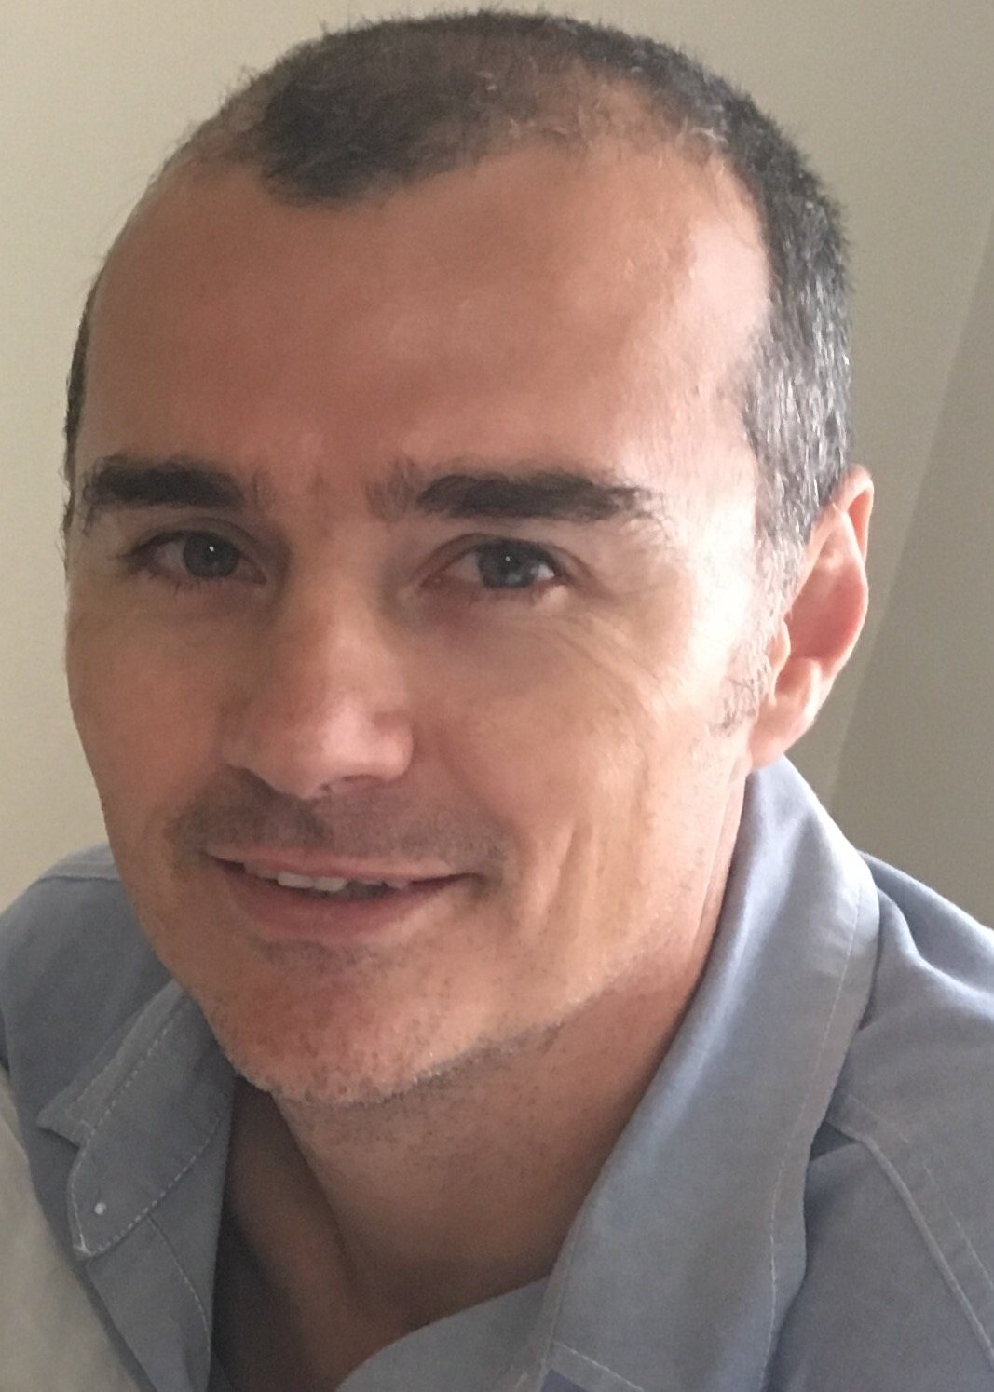

Marieta Bortoli Marilett Jenkins De Wet de Beer

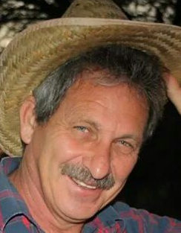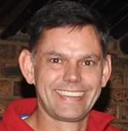
Hennie Venter André Breytenbach Kobus Stander

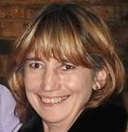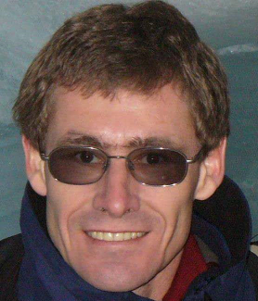
Marix Venter Fred Harding Gustav Brink (Ex-officio)

 Photo taken at the Knysa race

